Communications Toolkit
Agriculture Scams Awareness Campaign

10 October 2022
Contents

1. Purpose 3
2. Summary 3
3. Background on agriculture scams 3
4. Campaign resources 4
5. Additional resources 4
6. Social media content 5
Attachment one – social media images 7
Attachment two – information bulletins 7

Purpose
This document has been developed to provide some background information to the ACCC’s Agriculture Scams Awareness campaign and to make it easier for you to share the newsletter and social media material with your networks and members.

Summary
The ACCC is inviting you to share and distribute scam awareness material in support of our Agriculture Scams Awareness campaign running from 10 to 14 October.
The material created for this campaign is primarily aimed at farmers and small agricultural businesses. The resources provided to you include social media tiles to share via platforms such as Facebook, Twitter and Instagram, and information bulletins for printed magazines, newsletters, emails or any other appropriate channels.
The resources have been prepared by the ACCC. If you need to adapt them for your use, please ensure they remain factually accurate.
If you have questions or comments or require further information about this toolkit please contact the team via agricultureunit@accc.gov.au

Background on agriculture scams

Key points
- The ACCC’s Scamwatch has observed a rise in agriculture scams since the COVID-19 pandemic. According to the 2021 targeting scams report, farmers and small businesses lost over $1.5 million to scammers targeting the agriculture industry in 2021.
- An estimated one third of victims do not report scams to the ACCC and therefore the actual losses are believed to be higher.
- Reporting and acknowledging the impact of scams (not only financial) is important to encouraging scam awareness and prevention.
- Scams cause great emotional distress and trauma. Anyone who suspects they have given money or details to a scammer should talk to someone they trust or seek professional support.

Key statistics from scam reports made to the ACCC / Scamwatch in 2022 (1 January to 31 August)

Reports
- 292 reports of agriculture scams, with 219 about tractor or machinery scams
- Reported losses (not all scam reports involve reported losses)
  - Total amount lost to agriculture scams: $1.27m
  - Total amount lost to tractor/machinery scams: $1.03m
  - The average loss for tractor/machinery scams: $16,612

Demographics of scam reports
- People aged 55-64 made the most reports (67) with total losses of $233,550
- People aged 25-34 incurred the highest total reported losses ($440,275) from 24 reports
- NSW residents were most impacted with $373,487 in losses from 78 reports. This was followed by QLD residents with over $360,000 in losses from 88 reports

Most common types of ag scams
- 124 reports of online shopping scams with $663,882 in losses
- 124 reports of classified scams with $285,576 in losses

Campaign resources
From Monday 10 October to Friday 14 October, the ACCC’s Agriculture Unit will be running a campaign to raise awareness about scams impacting the agriculture industry. We will be issuing a media release about agriculture scams during this week. We encourage you to post the material provided during this week, for the campaign to have the most impact. You are also welcome to continue posting and sharing the material in the coming weeks if you wish.
The aim of the campaign is to raise awareness of scams that may affect farmers or people living in rural communities, in particular fake agriculture machinery, false invoice and romance scams.
Through this campaign, we will provide farmers and agriculture businesses with tips on what to look out for to protect themselves from scams, information on how to report scams and where to get assistance and information.
This toolkit comprises of:
- Social media content: Four social media posts have been developed for your use. Each post links back to the relevant webpage and has a recommended caption. These can be found at attachment one.
- Information Bulletin: Four information bulletins have been prepared covering different types of scams for use in newsletters, magazines, emails and updates to your members. These can be found at attachment two.
We encourage you to distribute these social media tiles and information bulletins through your networks. If you need to adapt the materials for your use, please ensure they remain factually accurate.

Additional resources

The Scamwatch and ACCC website contain a range of tools and resources that you can share with your members to raise awareness of scams:
- The Scamwatch websites provides up-to-date statistics on scams being reported by Australians. You can also find information on yearly trends and statistics in our Targeting Scams Reports.
- The Little Black Book of Scams can assist in identifying a scam (also available in a range of languages).
- Anyone can report scams anonymously via the Scamwatch Report Form. There does not have to be a financial loss suffered to report a scam.
- Scamwatch has advice on helping a friend or family member who is a victim to a scam.
- Videos produced as part of previous Scam Awareness Week campaigns are available.
- The Be Safe, Be Alert Online publication provides information about a number of organisations who might be able to help when someone has been scammed.
- Scamwatch also provides referrals to other organisations who might be able to help when someone has fallen victim to a scam.
- Scamwatch includes details of where to get help if you have been scammed.

Attachment one – Social media content
We encourage you to use these posts on your own social media channels. The graphics have been provided to you in square and landscape formats that can be used across most social media platforms according to your preferences.
For high resolution images, see Attachment One on email – Social Media Images.
Post | Image | Copy | Link to resource
1 | 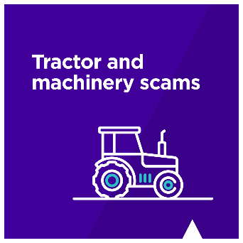 | Over $1.03M has been lost to tractor and machinery scams so far this year. Scammers can create fake websites and use online platforms to ‘sell’ machinery. They often say they’ll hold payment during a free-trial period and promise full refunds if you are not satisfied.  Do extra checks before buying online:  - Search online for the photos and wording used in the ad.  - Inspect the item before making any payment, including a deposit.  - Don’t make unsecure payments like bank transfers.  - If it’s a bargain price it’s probably too good to be true.  Report scams to Scamwatch. | https://www.scamwatch.gov.au?utm_source=partner&utm_medium=social&utm_campaign=ag_scams&utm_content=tractorscams
1 |  | Twitter copy (under 280 characters)  Over $1.03M was lost to tractor scams in 2022. If you're buying online:  - Research the seller  - Take your time  - Avoid bank transfers or payments before inspecting the machinery  - If it’s so cheap it’s probably too good to be true  Report scams to Scamwatch. | https://bit.ly/3T7fMbb
2 | 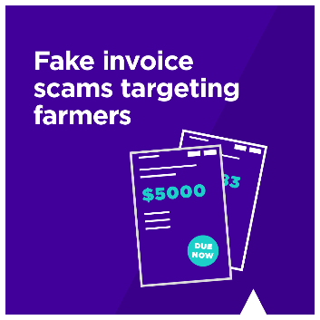 | Australian farmers have lost over $320,000 to fake invoice scams so far this year. Scammers often impersonate businesses and request payment of “invoices”. These may look exactly like an invoice you are expecting. Before paying:  - Check the email address is legitimate.  - If it’s a bill you’ve paid before, cross check the bank details.  - If suspicious or a large amount, call the biller to confirm (don’t use the phone number on the invoice).  Report scams to Scamwatch. | https://www.scamwatch.gov.au?utm_source=partner&utm_medium=social&utm_campaign=ag_scams&utm_content=fakeinvoice
2 |  | Twitter copy (under 280 characters Farmers have lost over $320K to fake invoice scams in 2022.  Before paying your invoice, call the biller first to confirm their bank details.  Don’t use the phone number on the invoice, it might be fake.  Report scams to Scamwatch. | https://bit.ly/3SRdDkr
3 | 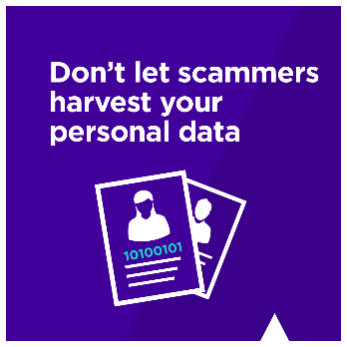 | Scammers target more than just money – they have eyes on your personal information too.  Protect yourself from identity theft:  - Use strong, unique passwords  - Be careful how much personal information you share and who you give it to  - Don’t send money or give copies of personal documents to anyone you don’t know or trust  - Check your bank transactions  If you think your identity has been stolen, contact IDCARE | https://www.idcare.org
3 |  | Twitter copy (under 280 characters)  Scammers target more than just money. Protect yourself from identity theft:  - Use strong, unique passwords  - Be careful how much personal information you share  - Check your bank transactions  If you think your identity has been stolen, contact IDCARE | https://www.idcare.org
4 | 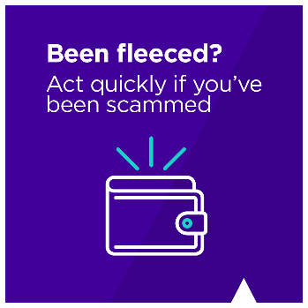 | Australians have lost $1.27 million to agriculture scams so far this year. If you’ve been scammed, take action quickly:  - Call your bank  - Contact IDCare to protect your identity  - Speak to someone you trust  - Report to Scamwatch | https://bit.ly/3SN5vRO (shortened link for Twitter)  or https://www.scamwatch.gov.au?utm_source=partner&utm_medium=social&utm_campaign=ag_scams&utm_content=beenfleeced

Attachment two – information bulletins
Note: Please see at the end of the attachment for four infographics which can be used to accompany the information bulletins.
High resolution images can be found in Attachment One to email – Social Media Images.

Ag machinery scams
Australian farmers and agri-businesses are the targets of tractor scams.
Between January 2021 and August 2022, the ACCC’s Scamwatch has received 533 reports about tractor and heavy machinery scams, including total losses of $2.6 million.
These scams were for new tractors, with scammers creating fake websites, and for second-hand sales on marketplace websites such as Facebook and Gumtree.
How tractor scams work
Fake tractor website scams
Scammers create fake websites that look like genuine online shops selling agricultural machinery. They may use sophisticated designs and layouts, photos and brand logos taken from other websites, a ‘.com.au’ domain name and even an Australian Business Number (ABN) taken from a legitimate business. The websites often have a physical business address listed on the website which are vacant blocks or belong to another business.
Second-hand tractor scams
Scammers will pose as genuine sellers and post fake ads on classifieds websites, in print classifieds, and on online platforms such as Gumtree and Facebook Marketplace. However, once a deposit is paid, the scammer usually ‘disappears’ and delivery is never made.
7 tips to avoid being scammed
- If it seems too good to be true, it probably is
Scammers advertise machinery at much lower prices than what the market rate is.
- Don’t purchase machinery if you haven’t seen it in person
Scammers will always come up with an excuse as to why you can’t inspect the machinery in person, or they will ask for a deposit first.
- Beware if they offer a ‘free trial’ or an ‘escrow’ service
Scammers may offer a ‘free trial’ in an attempt to earn your trust. However, they would ask for a deposit to be paid first.
Scammers may also reassure customers that the deposit is paid into a third party or ‘escrow’ account, but the ‘escrow’ service is also fake and part of the scam.
- Don’t rush into a purchase
Be cautious if the seller tries to make the sale feel urgent. For example, scammers often say that they need to sell quickly because they are in the army and about to be deployed overseas, or that their father has passed away and they need to get rid of machinery from their parent’s farm.
- Do your own research
Look for online reviews to see other people’s experience with the business. Do your research beyond the website itself, as those reviews may be fake.
Scammers may also steal other businesses’ names and ABN details for their website. If a physical address is listed, look it up online and see if it is the correct business on Google Maps. You could also call a neighbouring business to verify the seller.
- Be careful what personal details and information you provide
Be careful if you are asked to provide a driver’s licence, passport or home address, which may be used for identity theft. Where people reported losses as a result of a scam, more than half of them lost personal details.
- Speak to someone you trust
If you think the sale might be a scam, get a second opinion from a family member or a friend to see what they think.
Report a scam
We encourage you to report scams to the ACCC via the report a scam page. This helps the ACCC to warn people about current scams, monitor trends and disrupt scams where possible. Please include details of the scam contact you received, for example, email or screenshot.
Scamwatch also provides guidance on protecting yourself from scams and where to get help.

Fake invoices
Agri-businesses may be unknowingly paying fake invoices
Did you know that scammers sometimes send invoices that appear to be from real business suppliers, and you could pay them, not realising they are fake invoices until sometime later?
These are known as ‘fake invoice scams’ and between January and August 2022, the ACCC’s Scamwatch received 19 reports from farmers and agricultural businesses, with $320,572 in reported losses. Overall, over the same period, Australians lost $15,006,570 to fake invoice scams.
The scammers may hack into the email account of a business or supplier, and send you an email saying that their bank details have changed. These scammers can make invoices look almost identical to the real ones, with the only difference being the bank account details.
In one instance, a farmer paid a scammer’s fake invoice of over $60,000, as they believed they were paying an invoice for the purchase of machinery.
Protect yourself. What can you do to avoid being scammed?
Be careful if a business tells you they have updated their bank details
- If you receive an email containing an invoice that says the supplier’s bank details have been updated, you should call them to confirm this. Do not call the phone number on the invoice, as this may have been changed by the scammers. Instead, find the supplier’s phone number from another source.
- You should also confirm via a phone call that you have the right bank details, if it is the first time you are paying money to that supplier’s account, or for large purchases.

We encourage you to report scams to the ACCC via the report a scam page. This helps the ACCC to warn people about current scams, monitor trends and disrupt scams where possible. Please include details of the scam contact you received, for example, email or screenshot.
Scamwatch also provides guidance on protecting yourself from scams and where to get help.

Dating
Look out for the red flags of a romance scam
Over several months, scammers can build what feels like the romance of a lifetime. Attracting their targets with a fake online dating profile, they ‘love-bomb’ their targets with loving words, sharing ‘personal information’ and even by sending gifts.
Once they have gained your trust, they will usually find reasons to ask you for money, gifts or your banking or credit card details. For example, the scammer may claim they want to travel to visit you, but cannot afford it unless you are able to lend them money to cover flights or other travel expenses.
They may also ask you to send pictures or videos of yourself, possibly of an intimate nature.
Protect yourself:
- Never send money or personal photos to someone you haven’t met before in person.
- Do an image search of your admirer to help determine if they really are who they say they are. You can simply copy and paste their photos into image search services such as Google or TinEye.
- Be alert to things like spelling and grammar mistakes, inconsistencies in their stories and other signs that it’s a scam, such as their camera never working when you want to videocall.
Report the scam:

We encourage you to report scams to the ACCC via the report a scam page. This helps the ACCC to warn people about current scams, monitor trends and disrupt scams where possible. Please include details of the scam contact you received, for example, email or screenshot.
Scamwatch also provides guidance on protecting yourself from scams and where to get help.

General scams awareness
Protect yourself from scammers by being scam aware
Between January and August 2022, Australian farmers and agricultural businesses lost over $1.2 million to scammers. In total, Australians have lost over $300 million to scammers so far this year.
It can be difficult to recover any losses suffered from a scam and so it is important to stop them before they happen. The best way to do this is to report and raise awareness about scams, including common types of scams and what to look out for, to prevent more Australians from getting scammed.
The ACCC operates Scamwatch, which aims to help Australian consumers and small businesses recognise scams and avoid them by providing information about how to report scams and where to get help if they’ve been scammed.
Two common types of scams to look out for
Phishing scams
Phishing scams are attempts by scammers to trick you into giving out personal information such as bank account numbers, passwords, credit card details or personal information.
A scammer may contact you by email, phone call or text message and pretend to be from a legitimate business such as a bank or internet service provider. For example, they may pose as a bank seeking to ‘verify’ customer records.
To protect yourself from phishing scams, do not click any links or attachments in an email unless you are certain it is from a trusted organisation. If the email asks you to update or verify your details, this should be a warning sign.
Do an internet search using the names or exact wording of the email or message to check for any references to a scam. Many common scams can be identified in this way.
Remote access scams
A remote access scam happens when a scammer gets access to your computer after convincing you to download software to fix an internet or computer problem.
The scammer will usually phone you, pretending to be a from a large telecommunications or computer company such as Telstra, the NBN or Microsoft. They may also claim to be a technical support service provider.
Once they have remote access, scammers can access personal information stored on your computer, install malicious software or use your information for other crimes, such as identity theft.
To protect yourself from remote access scams, never give an unsolicited caller remote access to your computer. You should also never give your personal, credit card or online account details over the phone unless you made the call and the phone number came from a trusted source.
Find out more about scams
You can read more about these scams and other common scams on the ACCC’s Scamwatch page. Scamwatch also provides guidance on protecting yourself from scams and where to get help.

Infographic for the Agricultural machinery scam information bulletin
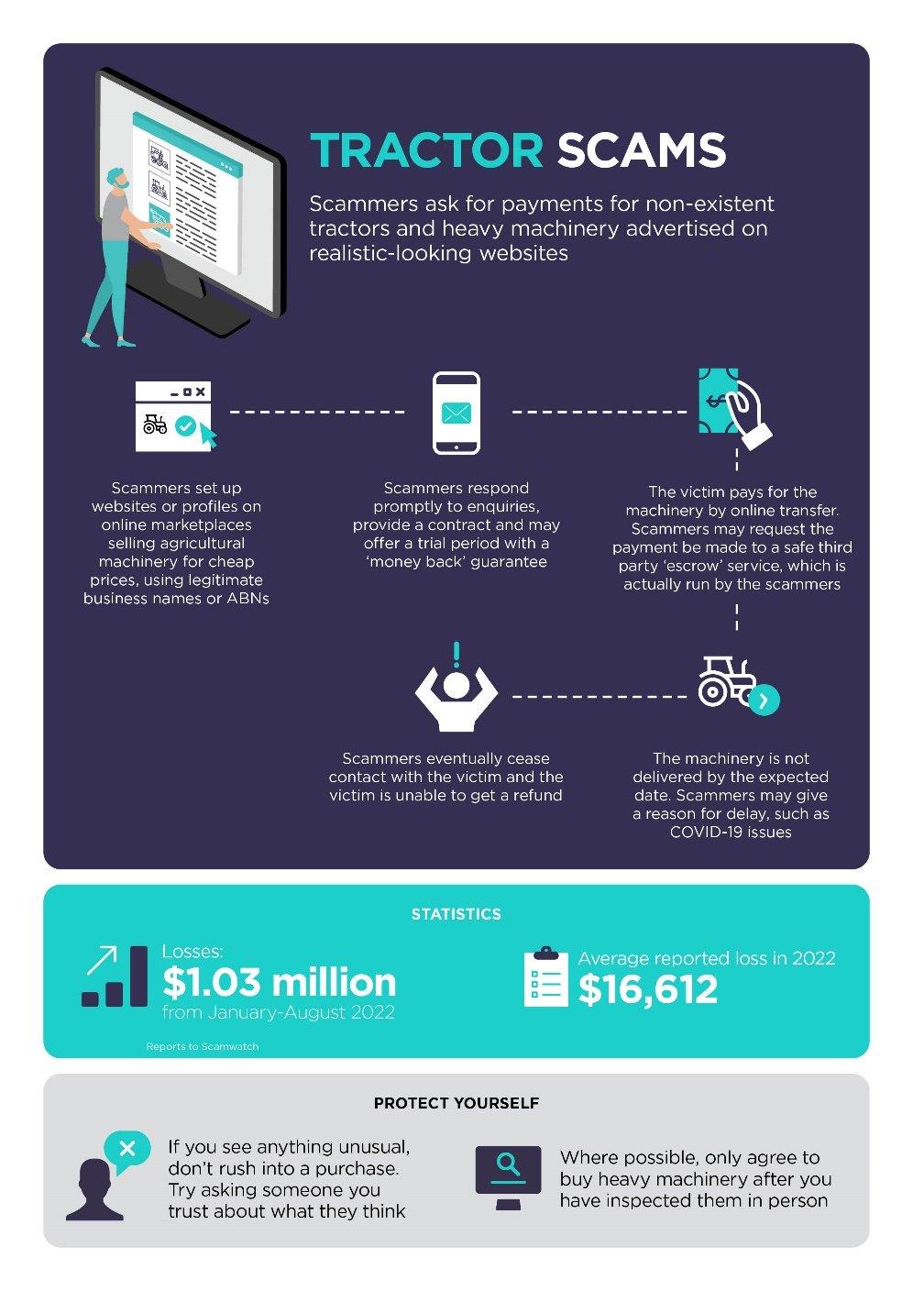

Infographic for romance scam information bulletin
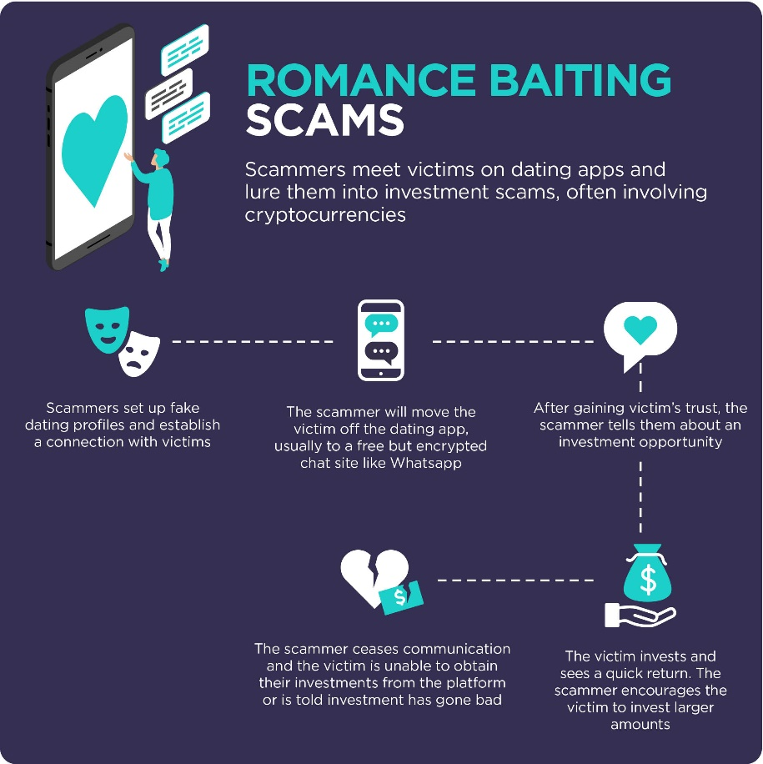

Infographic for remote access scam information bulletin
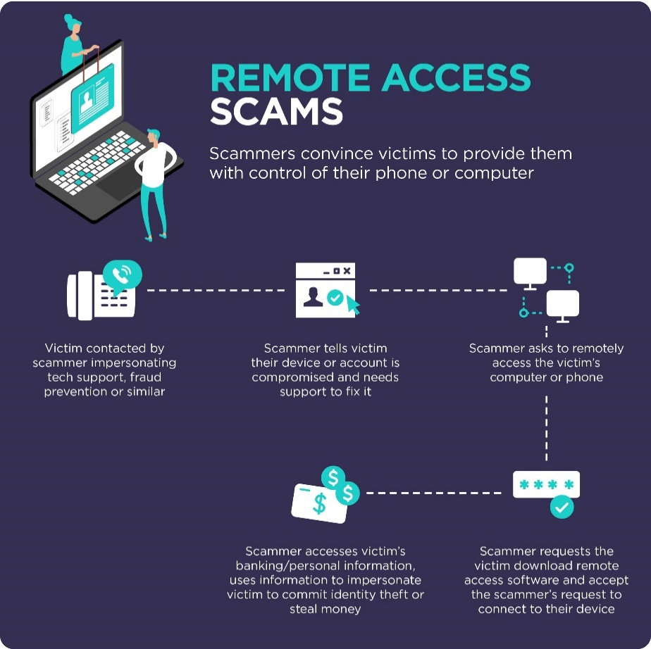

Infographic for phishing scam information bulletin
